**Requirements Specification**

Version: 0.1

April 14, 2016

Document ID: iTunes Example NEU 140416

Author: Richard Thomas

**Table of Contents**

Version History ii

1.0 Introduction 1

2.0 Packages 2

2.1 Package Diagram 2

3.0 Use Case Diagrams 3

3.1 Play Music 3

3.2 Streaming Services 3

3.3 Playlists 4

3.4 Music Search 4

3.5 Manage Music 5

3.6 Music Options 6

4.0 Actor Descriptions 7

5.0 Use Case Descriptions 8

5.1 Play Track 8

5.2 Play Track in Album 10

6.0 Activity Diagrams 11

6.1 11

7.0 Non-Funcational Requirements 12

8.0 Release Plan 13

8.1 Release One 13

8.2 Release Two 13

8.3 Release Three 13

8.4 Release Four 13

8.5 Release Five 13

9.0 Glossary 14

10.0 Summary 15

11.0 References 16

# Version History

|  |  |  |
| --- | --- | --- |
| **Issue** | **Date** | **Change** |
| 0.1 | 14/04/16 | Initial Version |
|  |  |  |

# Introduction

This document provides the requirements for the music player application on an Apple® device such as an iPhone® or iPad®.

# 2.0 Packages

|  |  |
| --- | --- |
| **Package Name** | **Description** |
| Play Music | Allow the music listener to play music in the music player. |
| Streaming Services | Allow the music listener to play music from a streaming service. |
| Playlists | Allow the music listener to create and manage playlists. |
| Music Search | Allow the music listener to find the music they want to play. |
| Manage Music | Manage the music available on the phone for the music player. |
| Music Options | Allow the music listener to adjust player and playback options. |

## 2.1 Package Diagram

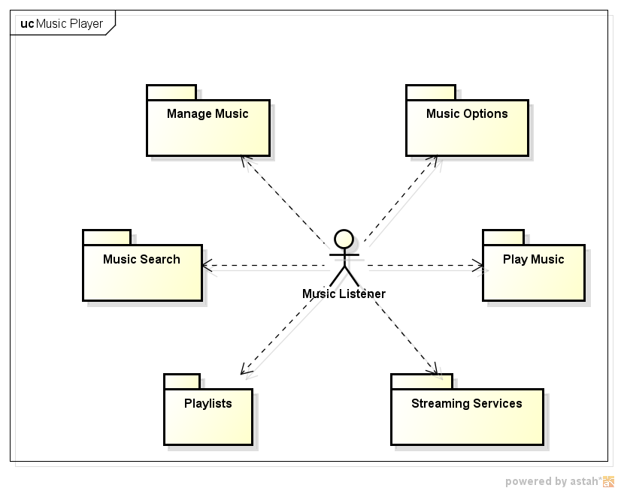

# 3.0 Use Case Diagrams

## 3.1 Play Music

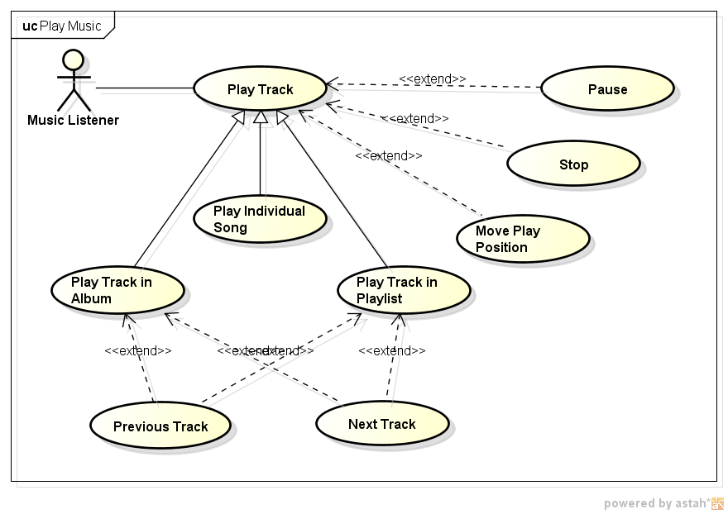

## 3.2 Streaming Services

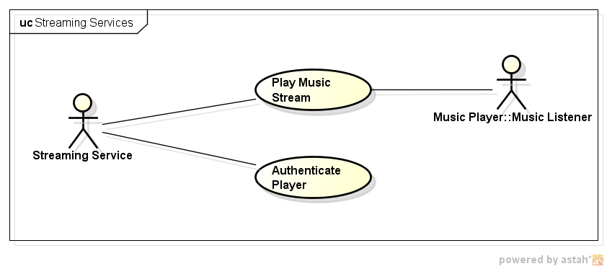

## 3.3 Playlists

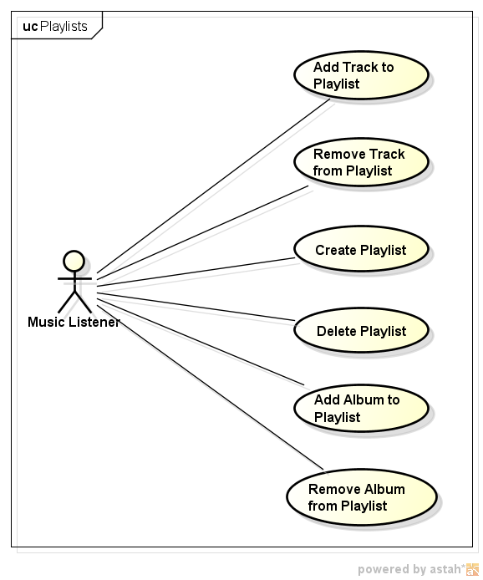

## 3.4 Music Search

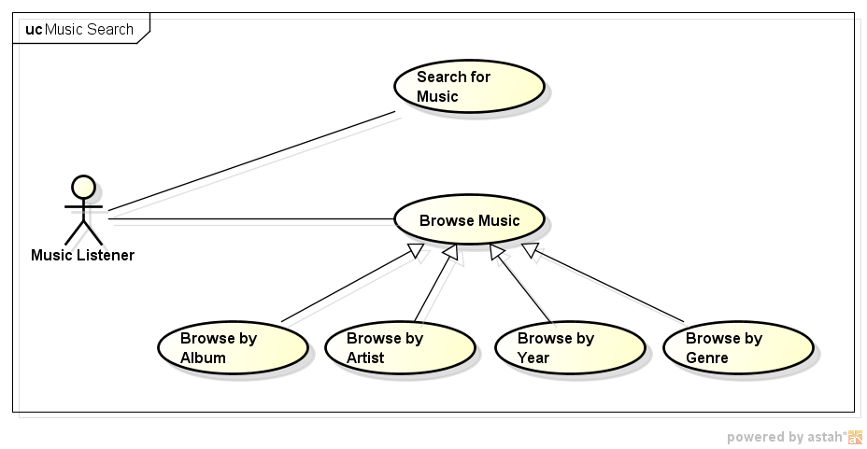

## 3.5 Manage Music

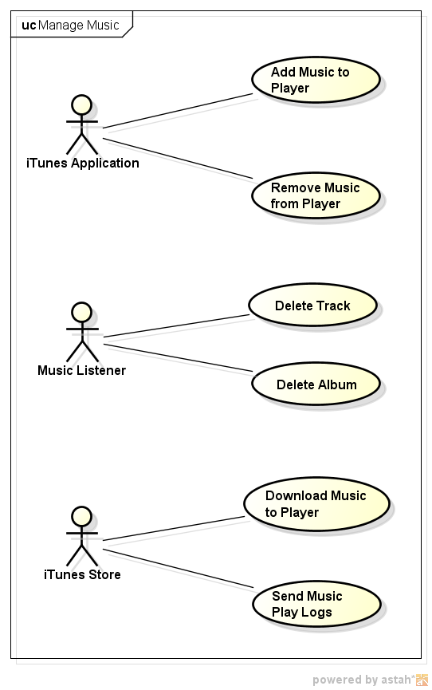

## 3.6 Music Options

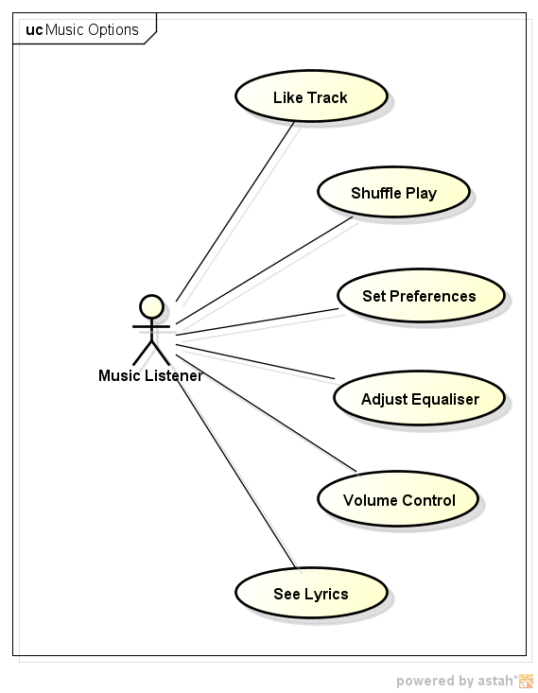

# 4.0 Actor Descriptions

|  |  |
| --- | --- |
| **Actor Name** | **Description** |
| Music Listener | The person who will use the music player to play music. |
| iTunes Application | The application that allows a user to manage their music library on a PC and sync it to their music player. |
| iTunes Store | The system that sells music and manages subscription services. |
| Streaming Service | A source of music, or other audio programmes, that can be streamed online. |

# 5.0 Use Case Descriptions

## 5.1 Play Track

|  |  |  |  |
| --- | --- | --- | --- |
| **Version** | 0.1 | **Date** | 14/04/16 |
| **Package** | Play Music | | |
| **Summary** | Play a music track that has been selected | | |
| **Primary Actor** | Music Listener | | |
| **Secondary Actors** |  | | |
| **Inherits** |  | | |
| **Includes** |  | | |
| **Extension Points** | Pause, Stop, Move Play Position | | |
| **Business Rules** |  | | |
| **Pre-Condition(s)** | A music track is selected. | | |

Typical Sequence of Events

|  |  |
| --- | --- |
| **Actor Stimulus** | **System Response** |
| 1. Select the play option for the current track. | 2.1 The music track is played through the device’s audio system. |
| 3. «extend» *Pause* «extend» *Stop* «extend» *Move Play Position* | 4. |

|  |  |
| --- | --- |
| **Post-Condition(s)** | The music track has been played. |

Alternative Sequences of Events

**Alternative 1: Corrupt File at step 2**

|  |  |
| --- | --- |
| **Actor Stimulus** | **System Response** |
|  | 2.1 Music file can’t be read when playing.  2.2 Provide error message to Music Listener.  2.3 Stop playing track. |

**Alternative 2: Headphones Removed at step 2**

|  |  |
| --- | --- |
| **Actor Stimulus** | **System Response** |
|  | 2.1 Headphones are removed from socket.  2.2 Stop playing track. |
|  |  |

**Alternative 3: Incoming Phone Call at step 2**

|  |  |
| --- | --- |
| **Actor Stimulus** | **System Response** |
|  | 2.1 Phone call is received while track is playing.  2.2 Pause song – fading out music and fading in ring tone. |
| 3.1 Music Listener answers phone call.  3.2 Music Listener terminates phone call. | 4.1 Resume play music track – fading in music. |

**Alternative 4: Phone is Turned Off at step 2**

|  |  |
| --- | --- |
| **Actor Stimulus** | **System Response** |
| 3.1 Music Listener turns phone off (or phone runs out of power). | 4.1 Stop playing track, or pause track, depending on song’s metadata requirement. |
|  |  |

|  |  |
| --- | --- |
| **Priority** | Must Have |
| **Outstanding Issues** |  |
| **Author** | Richard Thomas |
| **Business Owner** | SRA&D Class |
| **Notes** |  |
| **Version History** | Initial version |

## 5.2 Play Track in Album

|  |  |  |  |
| --- | --- | --- | --- |
| **Version** | 0.1 | **Date** | 14/04/16 |
| **Package** | Play Music | | |
| **Summary** | Play a music track from an album | | |
| **Primary Actor** | Music Listener | | |
| **Secondary Actors** |  | | |
| **Inherits** | Play Track | | |
| **Includes** |  | | |
| **Extension Points** | Previous Track, Next Track | | |
| **Business Rules** |  | | |
| **Pre-Condition(s)** |  | | |

Typical Sequence of Events

|  |  |
| --- | --- |
| **Actor Stimulus** | **System Response** |
| 1. | **«refine»**  2.2 At the end of the track the next track in the album is played.  2.3 After playing the last track in the album stop playing. |
| 3. «extend» *Previous Track* «extend» *Next Track* | 4. |

|  |  |
| --- | --- |
| **Post-Condition(s)** |  |

Alternative Sequences of Events

**Alternative 1: at step**

|  |  |
| --- | --- |
| **Actor Stimulus** | **System Response** |
|  |  |
|  |  |

|  |  |
| --- | --- |
| **Priority** | Must Have |
| **Outstanding Issues** |  |
| **Author** | Richard Thomas |
| **Business Owner** | SRA&D Class |
| **Notes** |  |
| **Version History** | Initial version |

# 6.0 Activity Diagrams

## 6.1

# 7.0 Non-Funcational Requirements

NFR1 Playing a track must occur in real time with no audio drop outs.

NFR2 Playing a track must not consume more than 65% of the device’s processing capability.

NFR3 The music player must be able to decode audio files in the following formats: AAC, HE-AAC, ALAC, MP3, AA, WAV and AIFF.

NFR4 The music player must be able to decode audio files up to 48KHz in frequency range.

# 8.0 Release Plan

## 8.1 Release One

The first release provides the core music play back functionality and consists of the following use cases:

|  |  |
| --- | --- |
| * Play Track * Play Track in Album * Add Music to Player * Remove Music from Player * Browse Music * Browse by Album | * Volume Control * Pause * Stop * Next Track * Previous Track |

## 8.2 Release Two

The second release provides a more complete music play back experience and provides the ability for the music player to interact directly with the iTunes store. The release consists of the following use cases:

|  |  |
| --- | --- |
| * Download Music to Player * Send Music Play Logs * Play Individual Song * Move Play Position | * Shuffle Play * Browse by Artist * Browse by Year * Browse by Genre |

## 8.3 Release Three

The third release provides playlist functionality and the ability to search for music on the device. The release consists of the following use cases:

|  |  |
| --- | --- |
| * Create Playlist * Delete Playlist * Add Track to Playlist * Remove Track from Playlist | * Add Album to Playlist * Remove Album from Playlist * Play Track in Playlist * Search for Music |

## 8.4 Release Four

The fourth release provides the ability to listen to music from a streaming service. The release consists of the following use cases:

|  |  |
| --- | --- |
| * Play Music Stream | * Authenticate Player |

## 8.5 Release Five

The fifth release allows the music listener to customise the music player to suit their usage. The release consists of the following use cases:

|  |  |
| --- | --- |
| * Like Track * Set Preferences * Adjust Equaliser | * See Lyrics * Delete Track * Delete Album |

# 9.0 Glossary

|  |  |
| --- | --- |
| **Term** | **Definition** |
| Track | A single song file. |
| Album | A set of songs that have been packaged together by an artist. |
| Playlist | A set of songs that have been packaged together by the music listener. |
| Streaming Service | An online music source that provides access to a curated music channel. |

# 10.0 Summary

The requirements described in this document provide the details of what needs to be delivered for the music player on an Apple® device, such as an iPhone® or iPad®.

# 11.0 References

Apple iPod Touch Technical Specifications. http://www.apple.com/ipod-touch/specs/ [Accessed: 14/04/2016].